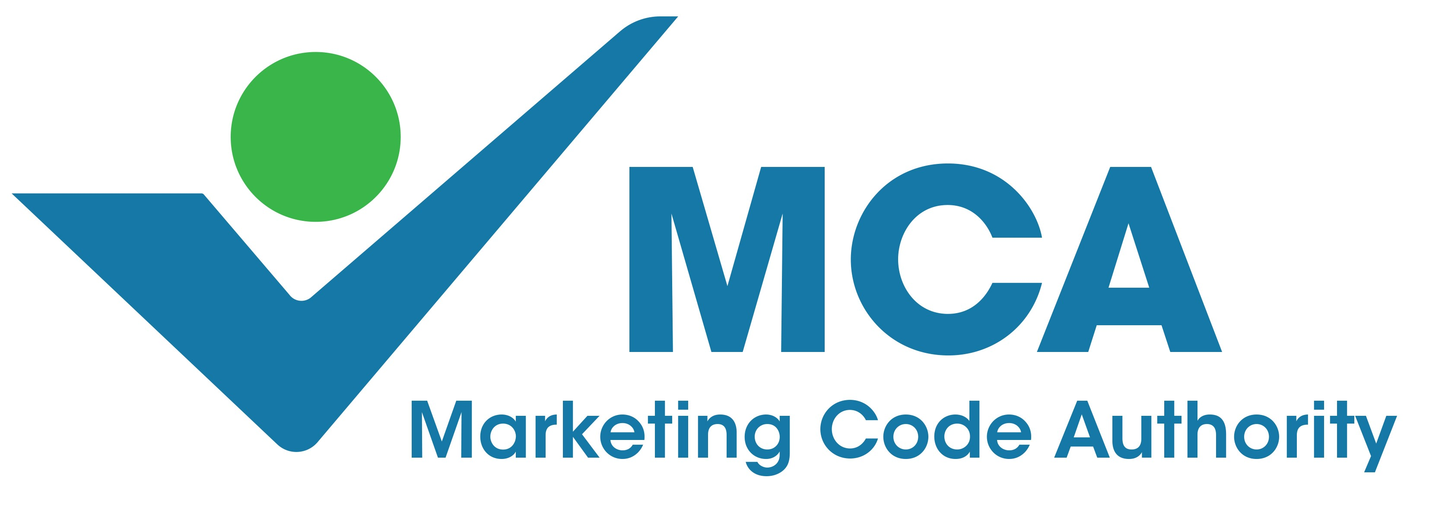
APPEAL IN TERMS OF THE CODE OF MARKETING PRACTICE
Kindly submit the Appeal to info@marketingcode.co.za
Complaints and Appeals should where possible be initiated and administered by the Compliance Officer or the Responsible Pharmacist for medicines or the Compliance Officer or Authorised person for medical devices and IVDs.

Date: _________________
Case Number Issued by the MCA: ____________________
DETAILS OF COMPLAINANT:
- Appellant
  - Name of Company: ______________________________________________________
  - Name of CEO: ______________________________________________________
- Company Representative (Code Compliance Officer) liodging this Appeal
  - Full Names and Surname: ____________________________________________________________
  - Job Title:
_____________________________________________________________
2.2. Qualification: ___________________________________________________________
  - Date of latest “Code certification” with the MCA: ______________________________
  - E-mail Address: _______________________________________________

  - Mobile Number: ______________________________________________
  - Work Telephone Number: ______________________________________

- DETAILS of the person/organisation who is the subject of the Appeal.
  - Product which is the subject of the Appeal? (If more than one product in a range is implicated, mention all dosage forms).
______________________________________________________________
  - Name of Company/Individual/Organisation appealed against: _____________________________________________________________
  - Name of the Company Representative
_________________________________________________
  - Contact Details of Company Representative
E-mail Address: ________________________________________________
Mobile Number: ________________________________________________
Work Telephone Number: ________________________________________
NATURE OF APPEAL
- Rulings of the Adjudicating Committee that are being appealed against.
It is necessary to be specific and clear. The Executive Officer may return this notice if it is not clear exactly what is being appealed against.

Reference to Adjudicating Committee Report | Details of appeal in each section. | Reason for Appeal.

- Confirm that in terms of code and MCA requirements, the following documents are attached?
  - Appeal Lodging Fee – Proof of Payment (R2850 incl. VAT)
Yes |  | No
  - Supporting arguments below in this form
Yes |  |  | No |  | N/A

No new information may be submitted
- Submit below, any other information considered relevant to the determination of the Appeal?
Please include below, your motivation for the Appeal. Please align your comments with the table above and reference comments and related documents to the Adjudicating Committee Report.

It is important to consider the nature and extent of your Appeal carefully in compiling this form as no additional matters or related documents will normally be admitted. You are referred to the Code for the Appeal process. Additional issues or angles may not be raised.
Notes for clarity on processes to be followed in the administration of the Appeal. Adjudication of an Appeal is the responsibility of an appointed Adjudicating Committee.
The Appeal pack will be recorded and submitted to the Appellee. Documentation should be logically compiled, pages numbered and scanned to PDF to ensure the integrity of the submission.
- The Executive officer will forward the pack to the Appellee and request a formal response, as soon as possible after receipt and no later than 7 working days from the date of receipt by the MCA.
- The Appellee will have an opportunity to respond within 7 working days of receiving the Appeal pack.
- Any reply from the respondent will be sent within two working days to the Appellant with an invitation to respond.
- No additional issues may be raised or, additional substantiating data submitted. The Appellant should indicate whether they wish to withdraw the Appeal at this stage or proceed the Appeal. The Appellant’s reply will be shared with the respondent.
- Within 12 days an Appeal Committee will consider the matter as directed by the Code.
- Unless explicit approval is granted following the processes documented in the Code for the admission of further supplementary evidence, the sequence of correspondence referred to above together with the Complaint pack and the Adjudicating Committee Report, will be the only documentation that will be considered by the appointed Appeal committee.
____________________________ | ____________________________
Signature of Responsible Person | Date
____________________________
Name of Responsible Person

In the event that this Appeal has already been lodged with another entity, the MCA will only process the Appeal after such Appeal has been finalised by such entity and the outcome released.
If assistance is required contact the Executive Director, Val Beaumont on 0828283256

